**INDEX**

1) Create a table called "books" with columns for "id" (primary key), "title," "author," and "publication_year." Insert some sample data into the table.

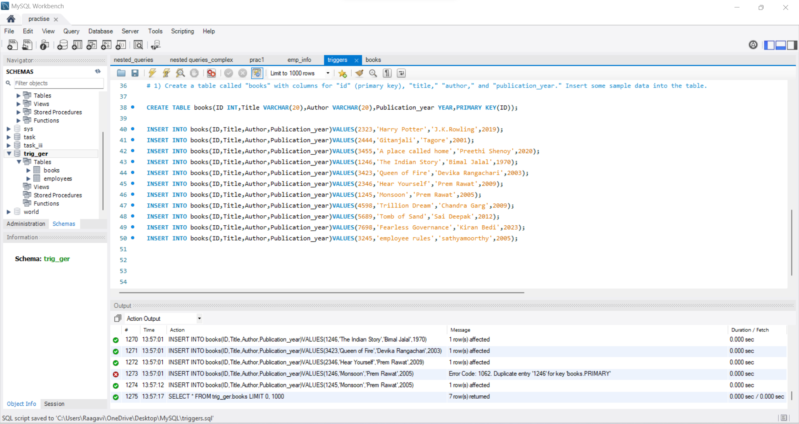

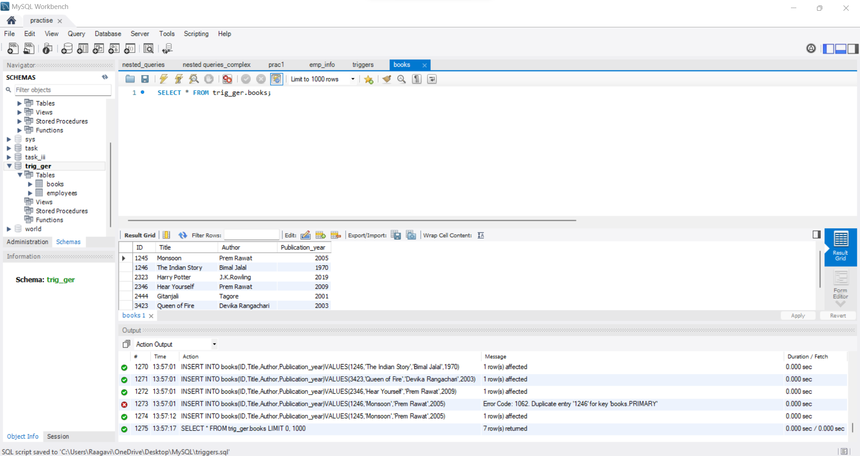

2) Write a SQL query to retrieve all books written by a specific author, e.g., "J.K. Rowling," and explain how an index could improve the query's performance.

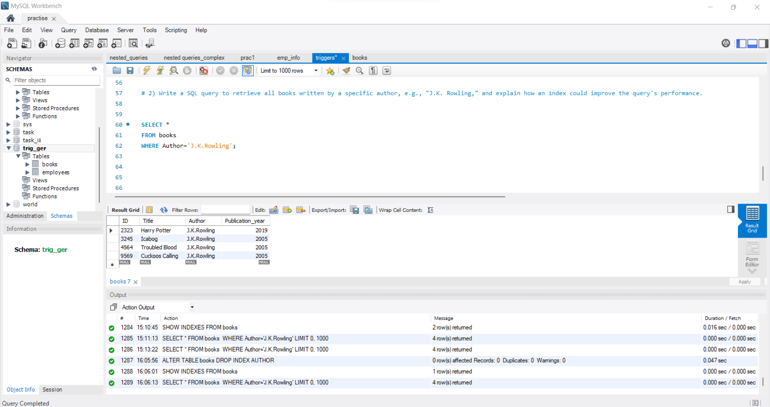

* Indexing helps to retrieve the data in a very fast manner.
* For example, If we have some trillion values of data and when we want to find some particular data from the table we can indexing method to retrieve the data fastly.

3) Add an index to the "publication_year" column in the "books" table and compare the query performance before and after adding the index.

**BEFORE ADDING INDEX:** It takes 0.16 Sec to retrieve the data

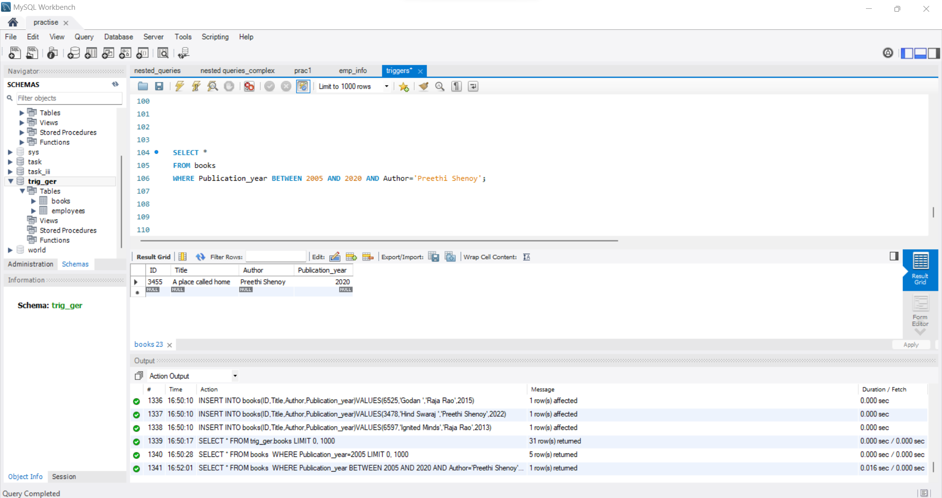

**AFTER ADDING INDEX:** It just returns the data as soon as it compiles the query.i.e It does not take 0.16 sec .

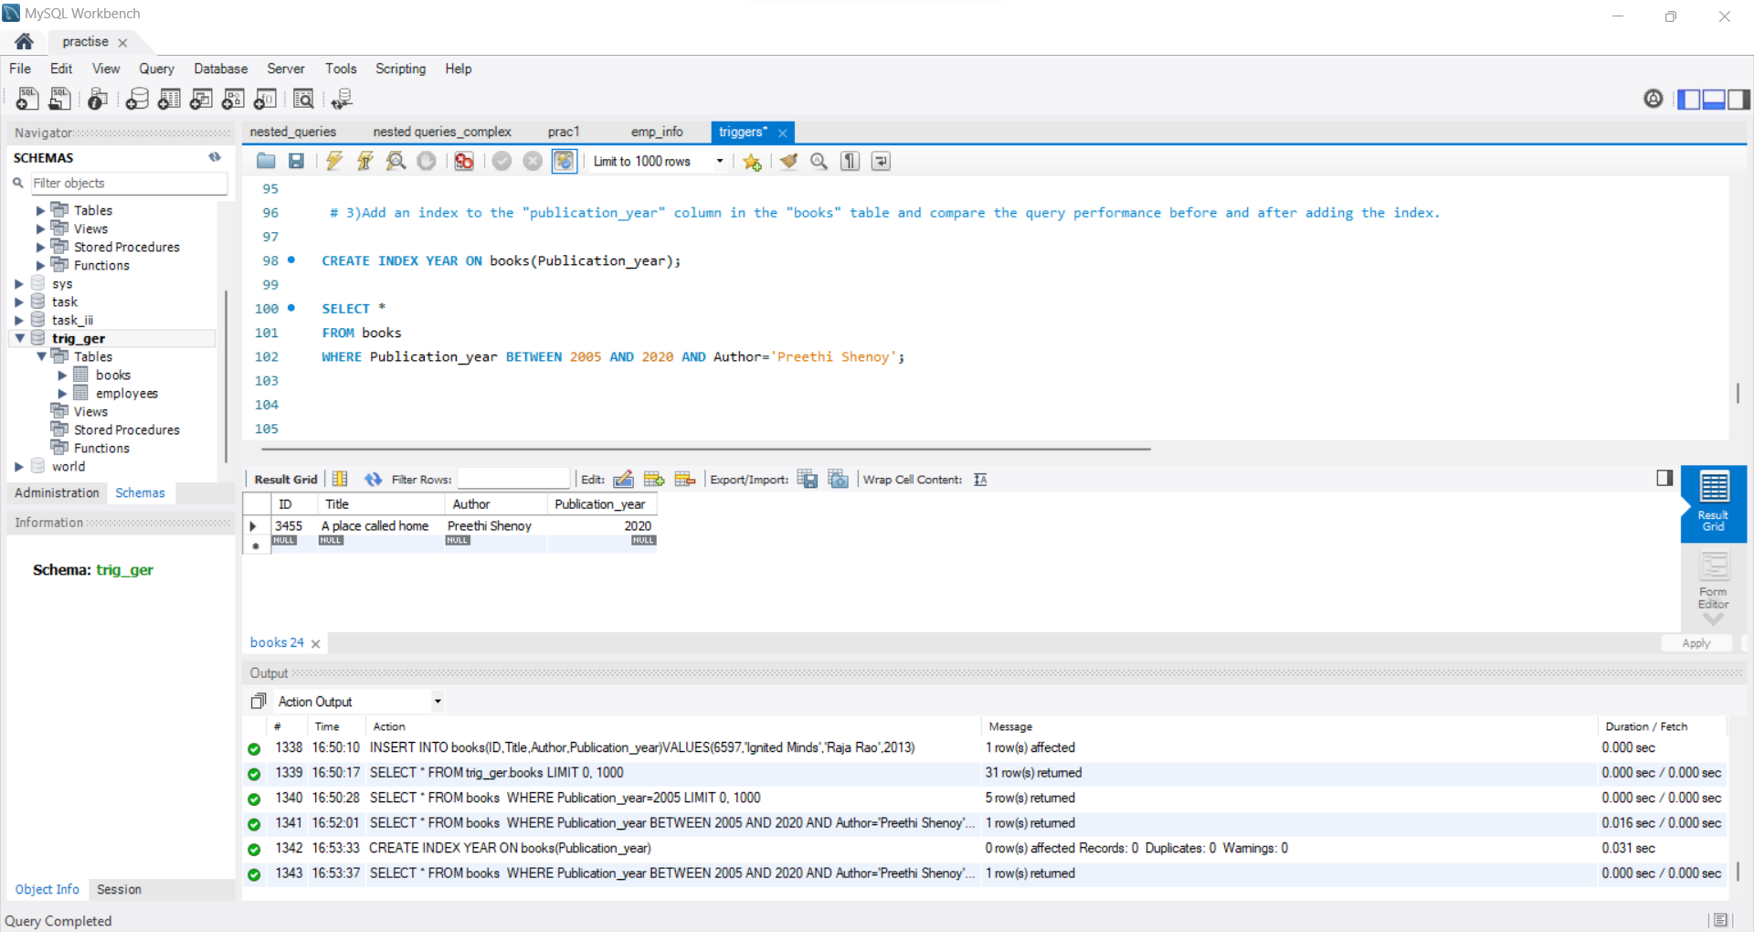

4) Create a table called "students" with columns for "id" (primary key), "name," "age," and "grade." Insert some sample data into the table.

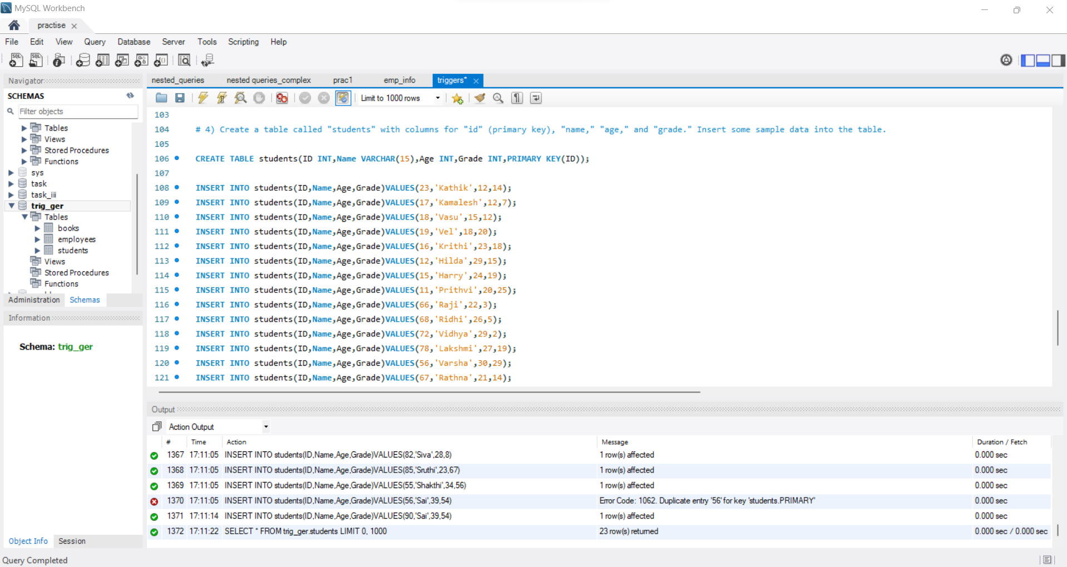

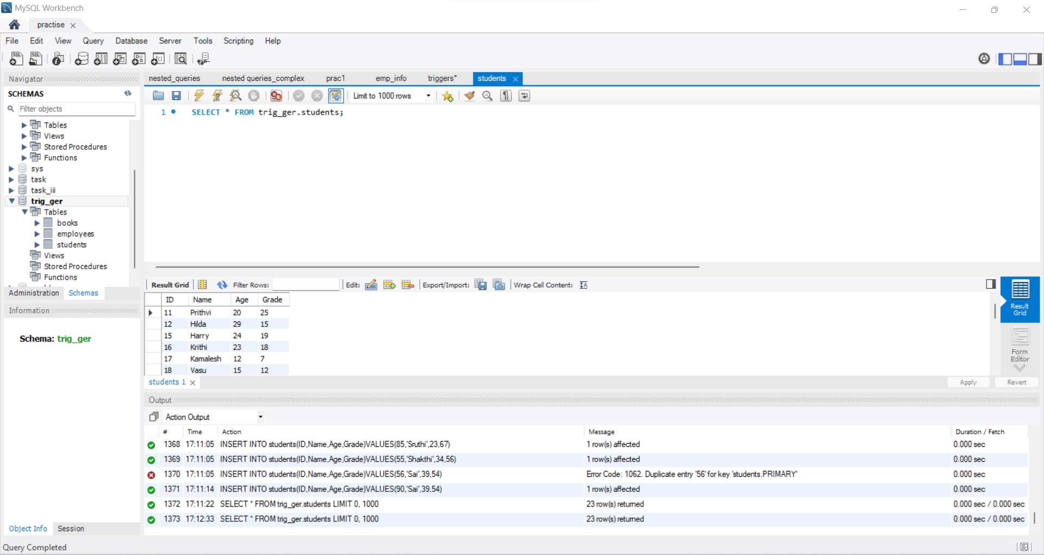

5) Design an index strategy to optimize queries for finding all students with a specific grade, e.g., Grade10.

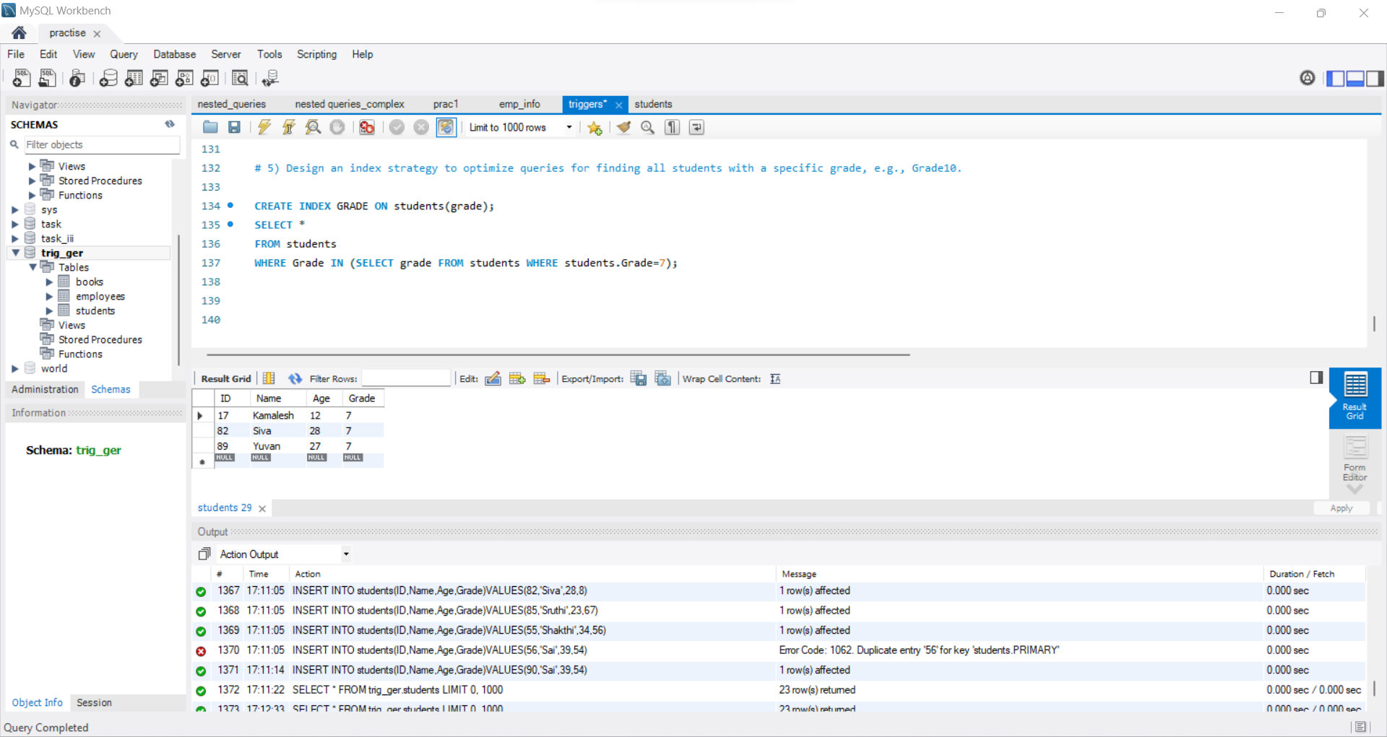

**TRIGGERS**

1)Create a trigger that automatically updates the "last_updated" column in a table called "employees" whenever a row is updated.

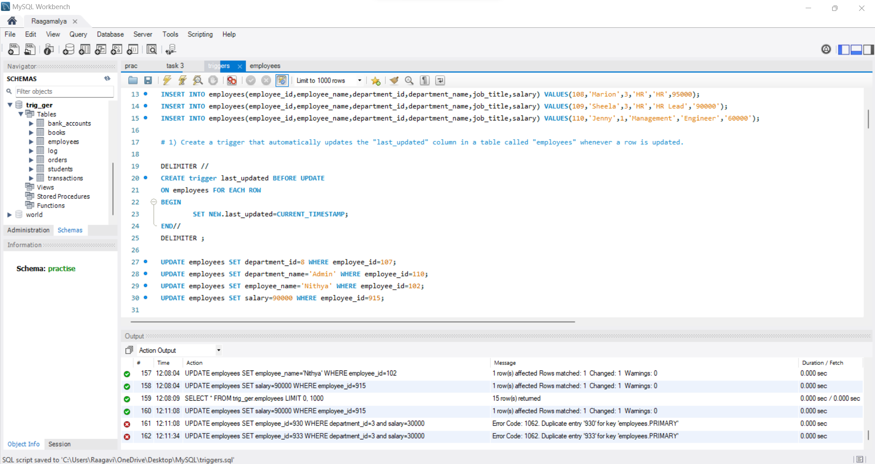

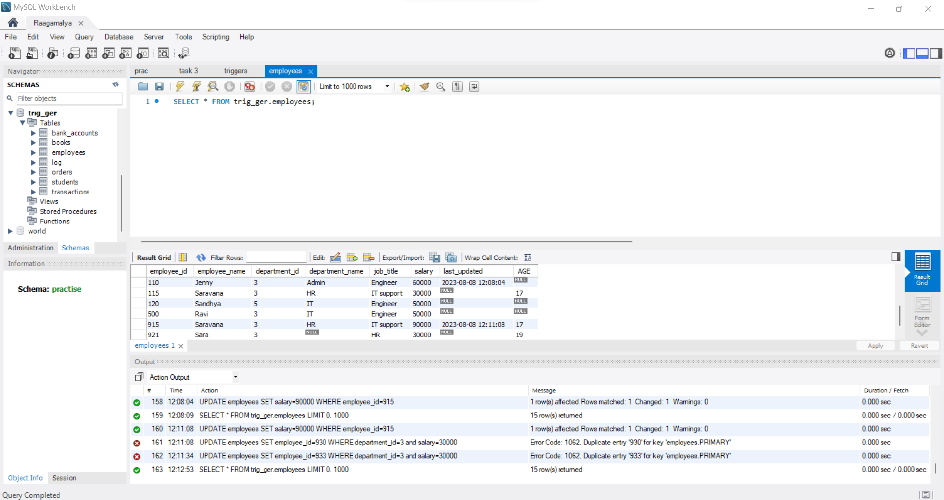

2) Write a trigger that inserts a new row into a "log" table whenever a record is deleted from the "orders" table.

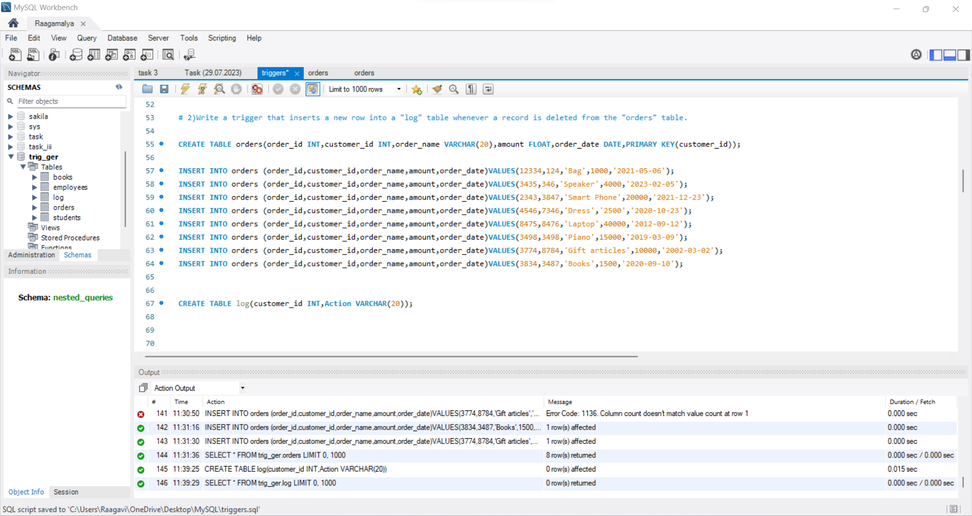

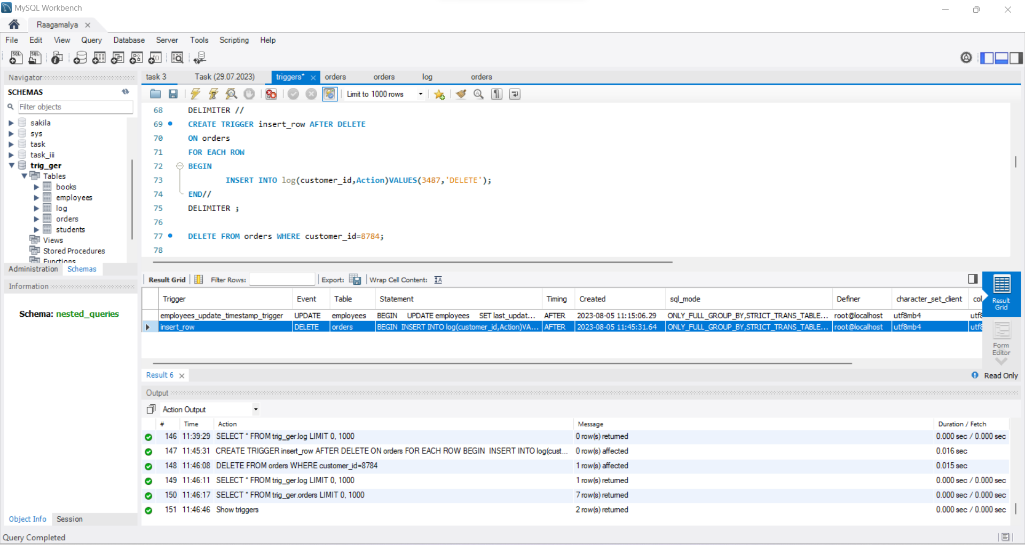

Orders Table: Here a row is deleted.

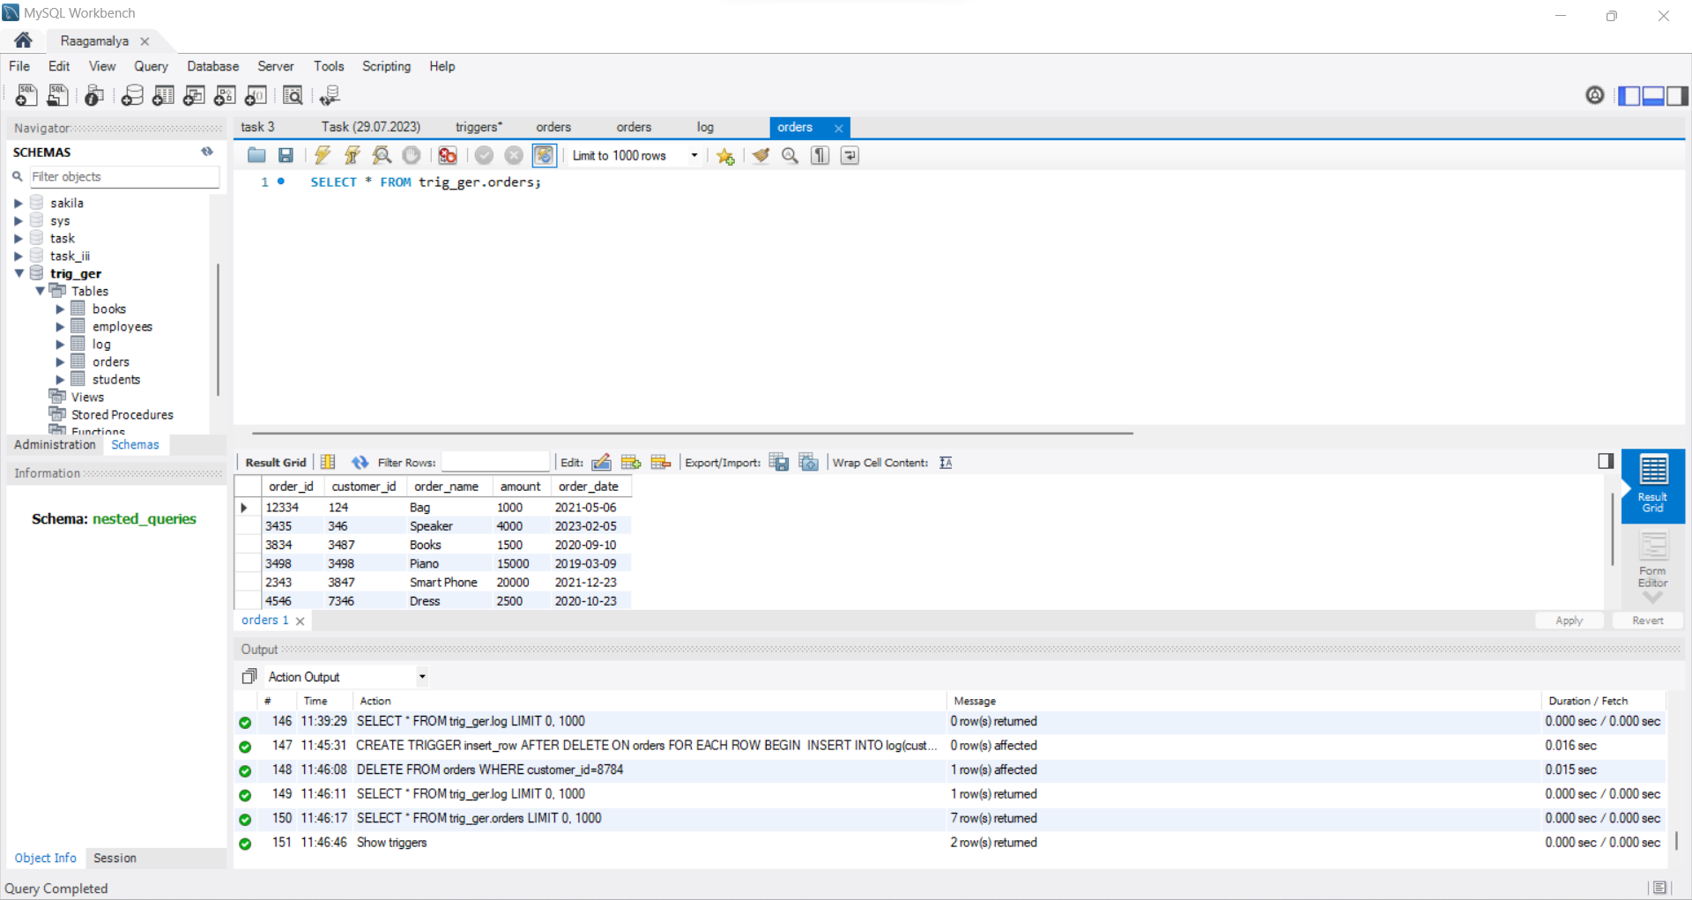

Log Table: A row is inserted in the log table after row is deleted in the orders table

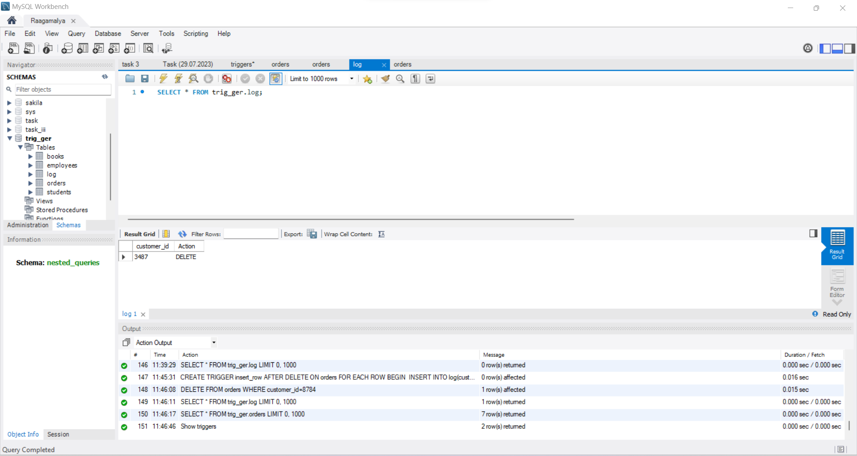

3) Create a table called "transactions" with columns for "id" (primary key), "amount," and "timestamp." Create a trigger that updates the "balance" column in a "bank_accounts" table whenever a new transaction is inserted, considering the transaction amount (debit or credit).

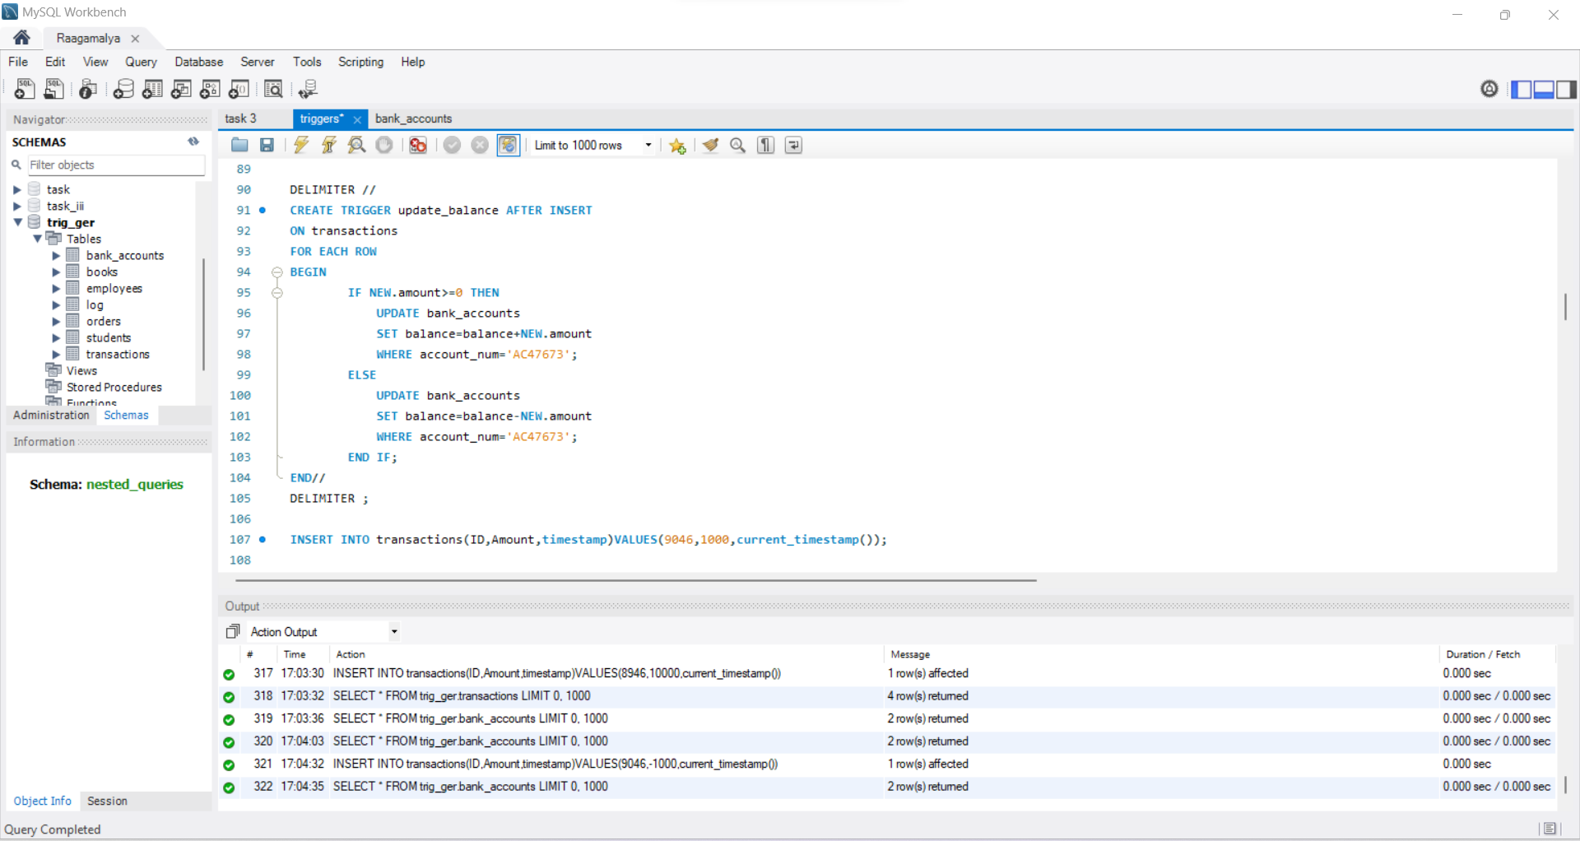

4) Write a trigger that prevents inserting a new record into the "employees" table if the employee's age is less than 18.

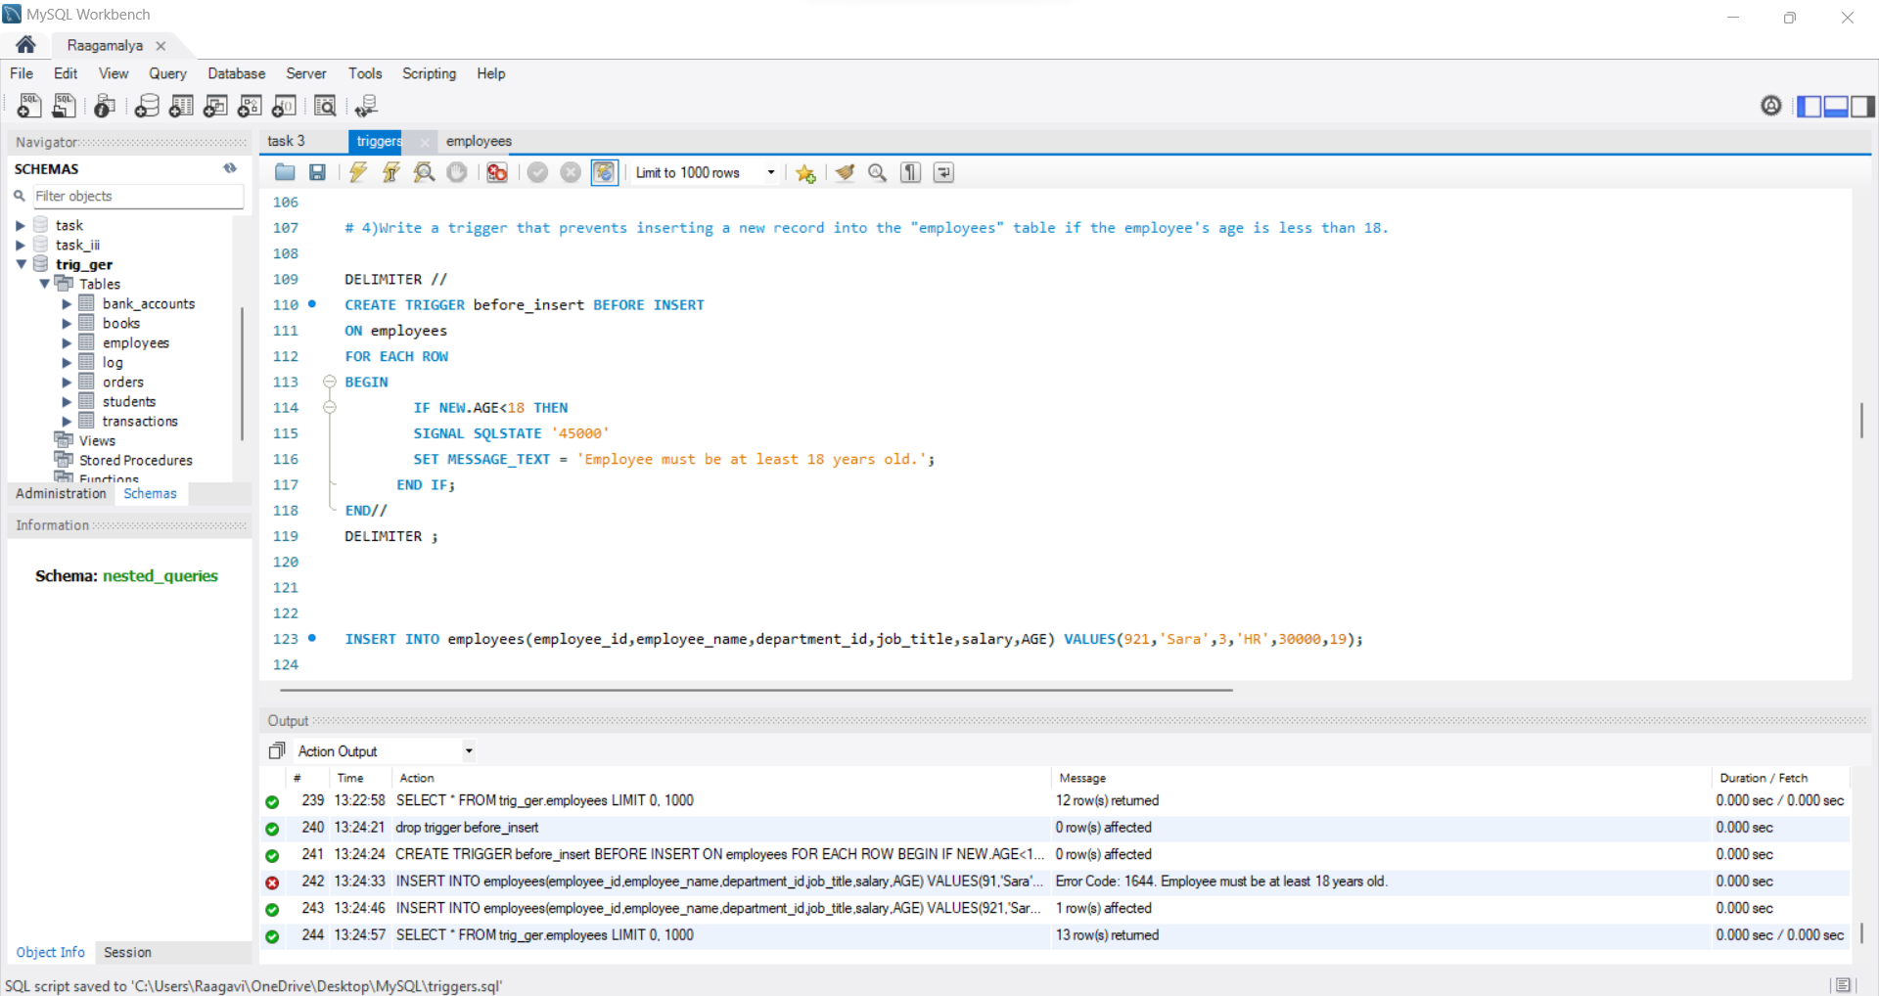

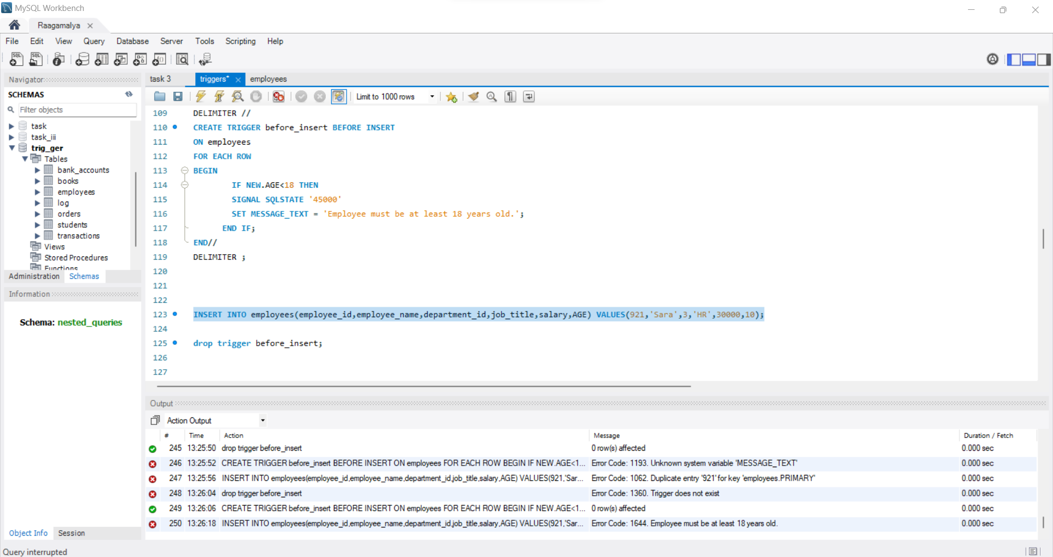

5) Create a trigger that sends an email notification to a specified email address whenever a new order is placed in the "orders" table.

